DBMS PROJECT

ON

***STUDENTS***

***DATABASE***

***Designed by***

**P Lakshmi Sahithi**

**K Durga Prasanna**

**K Satya Eswari**

## Problem Statement

This database aims at providing a centralized view of data of students in the university. It is mandatory for every institute to maintain a database to store data of students and their faculty. This database provides information regarding hostel, mess, library, sports, academics of students.

## Entity Relationship Diagram

This Entity–relationship model (ER model) describes the structure students database.

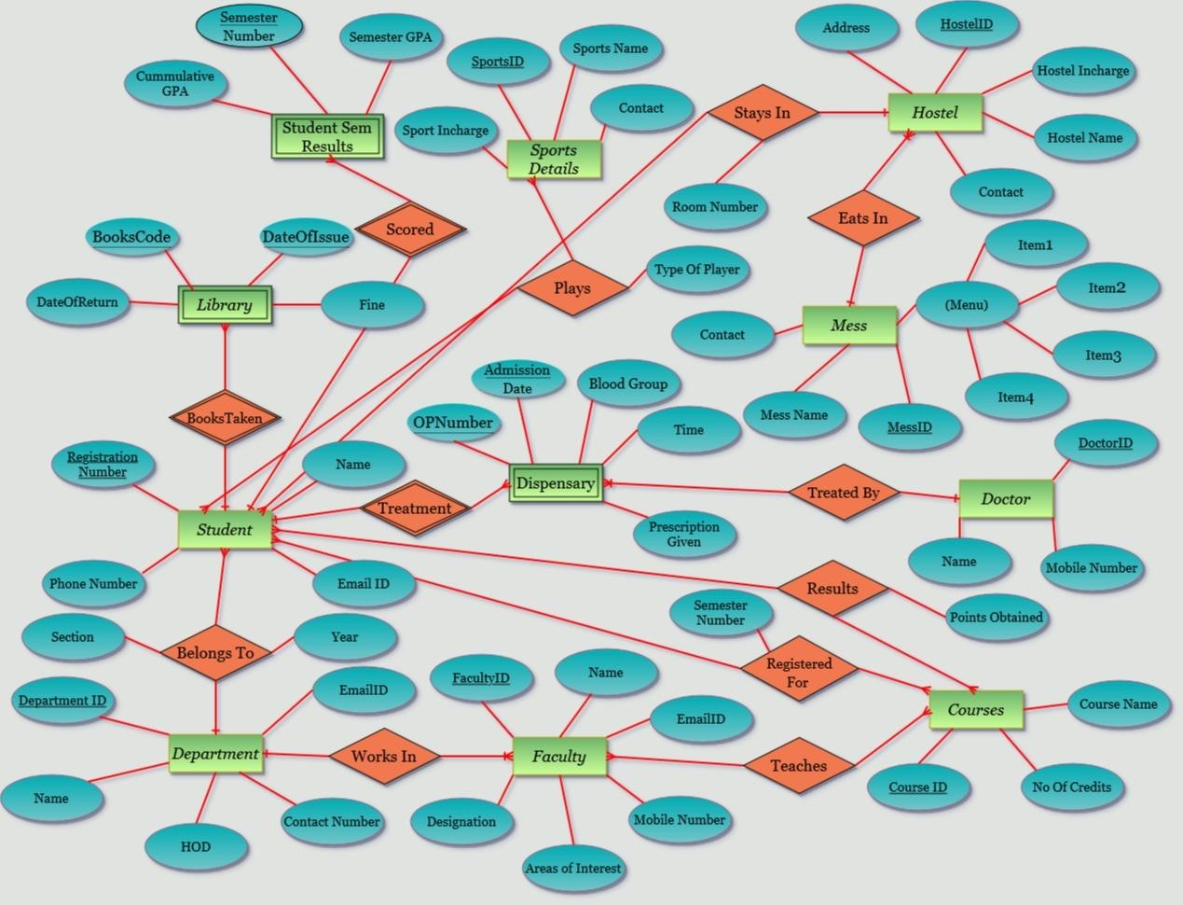

**Relational Schema**

**Entity:** **mess** **Attributes:**

* MessID (Primary Key)
* MessName
* Contact
* Menu (Composite attribute with values item1, item2, item3, item4)

**Entity: hostel Attributes:**

* HostelID (Primary Key)
* HostelName
* HostelIncharge
* Address
* Contact
* MessID (Foreign Key Referenced from ‘mess’)

**Entity: sportsdetails Attributes:**

* SportsID (Primary Key)
* Sportsname
* SportIncharge
* Contact

**Entity: department Attributes:**

* DepartmentID (Primary Key)
* Name
* HOD
* ContactNumber
* EmailID

### faculty

FacultyID (Primary Key)

DepartmentID (Foreign Key Referenced from ‘department’)

* Name
* MobileNumber
* AreasOfInterest
* Designation
* EmailID

**Entity: courses Attributes:**

* CourseID (Primary Key)
* NumberOfCredits
* CourseName

**Entity: teaches Attributes:**

* FacultyID (Foreign Key Referenced from ‘faculty’)
* CourseID(Foreign Key Referenced from ‘courses) Primary Key - (FacultyID, CourseID)

**Entity: student Attributes:**

* RegistrationNumber (Primary Key)
* Name
* Year
* Section
* EmaiID
* PhoneNumber
* DepartmentID (Foreign Key Referenced from ‘department’)
* HostelID (Foreign Key Referenced from ‘hostel’)
* RoomNumber

### plays

RegistrationNumber (Foreign Key Referenced from ‘student’)

SportsID (Foreign Key Referenced from ‘sportsdetails’)

* TypeOfPlayer

**Entity: library Attributes:**

* RegistrationNumber (Foreign Key Referenced from ‘student’)
* BookCode (Discriminator for weak entity)
* DateOfIssue (Discriminator for weak entity)
* DateOfReturn
* Fine

Primary Key - (RegistrationNumber, BookCode, DateOfIssue)

**Entity: doctor Attributes:**

* DoctorID (Primary Key)
* Name
* MobileNumber

**Entity: dispensary Attributes:**

* RegistrationNumber (Foreign Key Referenced from ‘student’)
* OpNumber (Discriminator for weak entity)
* AdmissionDate (Discriminator for weak entity)
* BloodGroup
* Time
* DoctorID (Foreign Key Referenced from ‘doctor’)
* Prescription

Primary Key – (RegistrationNumber, OpNumber, AdmissionDate) **studentsemresults**

RegistrationNumber (Foreign Key Referenced from ‘student’)

SemesterNumber (Discriminator for weak entity)

* SemesterGPA
* CumulativeGPA

Primary Key – (RegistrationNumber, SemesterNumber)

**Entity: results Attributes:**

* RegistrationNumber (Foreign Key Referenced from ‘student’)
* CourseID (Foreign Key Referenced from ‘courses’) ➢ PointsObtained

Primary Key – (RegistrationNumber, CourseID)

**Entity: registeredfor Attributes:**

* RegistrationNumber (Foreign Key Referenced from ‘student’)
* CourseID (Foreign Key Referenced from ‘courses’) ➢ SemesterNumber

Primary Key – (RegistrationNumber, CourseID)

### Normalisation of Tables

**Normalization:**

**1NF**

* A Table is in 1NF when all the attributes contain atomic values(cannot be divided further)
* No Duplicate rows are allowed.
* A Column should contain value from the same domain.

**Here, In this Database all the tables contain single valued attributes and composite valued attributes are divided into columns So, All the tables are in 1NF.**

**2NF**

* It should be in 1NF.
* There should not be any functional dependency

**Here, In this Database as we have only tables those have a single candidate key and which is a primary and all also any proper subset of this candidate key do not form any functional dependency with other non-prime attributes. So, All the Tables are in 2NF.**

**3NF**

* It should be in 2NF.
* No Transitive Dependency for non-prime attributes.

**Here, In this Database only dependency exists for candidate key so there is not possibility of having any transitive dependency. There, they are in 3NF.**

**BCNF**

* It should be in 3NF.
* For each non-trivial dependency, the left hand side of dependency is super key.

**Here, As in all the functional dependencies the determinant is candidate key. So the tables are in BCNF.**

### Actual Database Creation SQL Queries

**Creati**

**on**

**of Ta**

**bles:**

**Table**

**:**

**mess**

**Table**

**:**

**hostel**

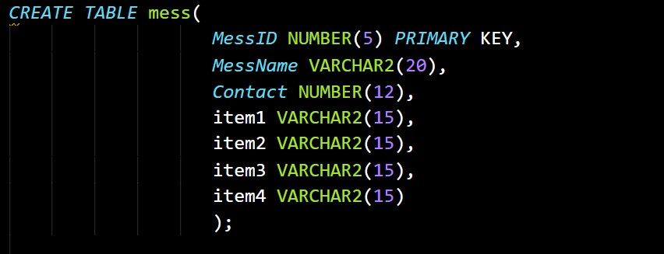

**Table**

**:**

**sportsdetails**

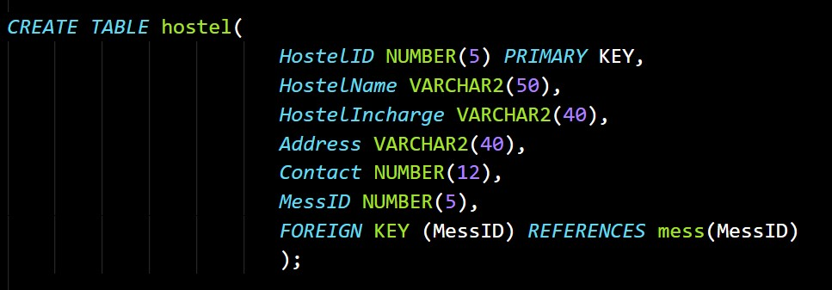

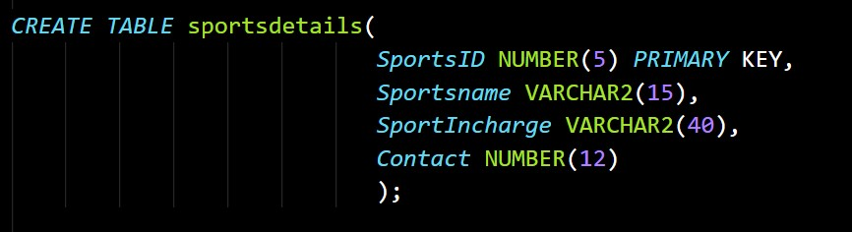

#### department

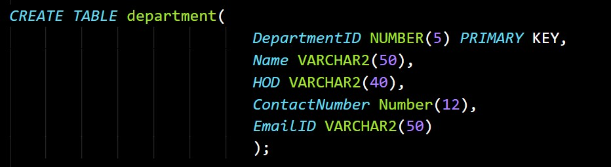

#### Table: faculty

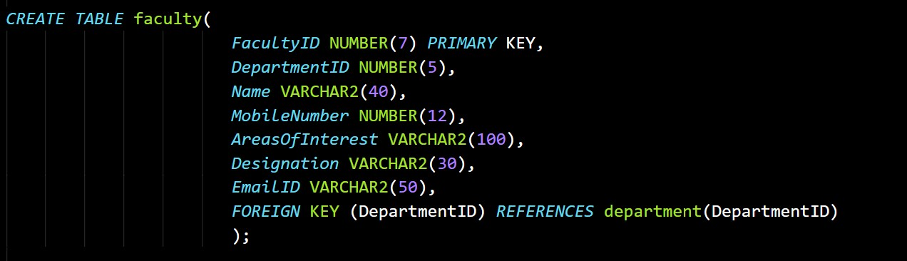

#### Table: courses

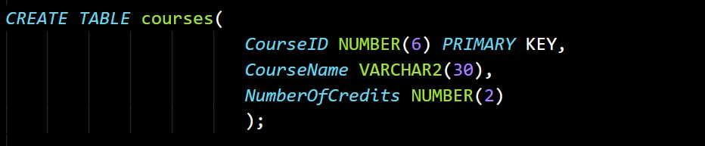

#### Table: teaches

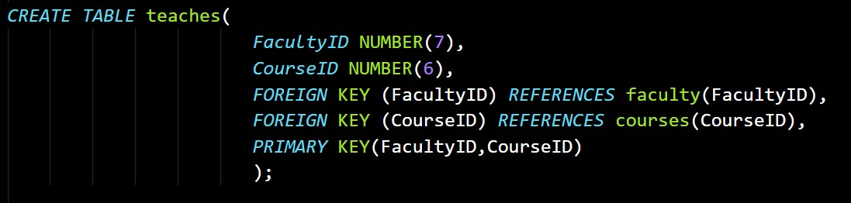

#### student

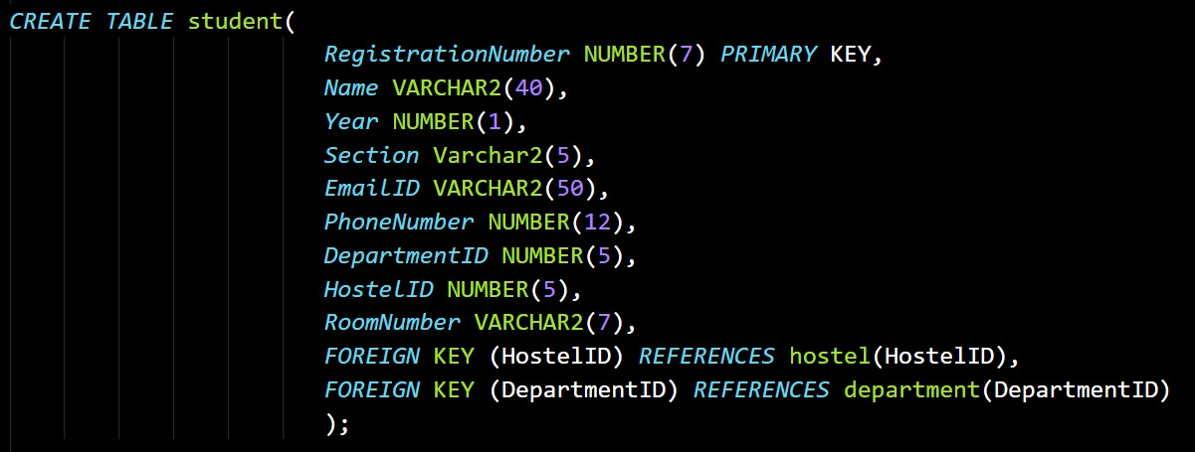

**Table: plays**

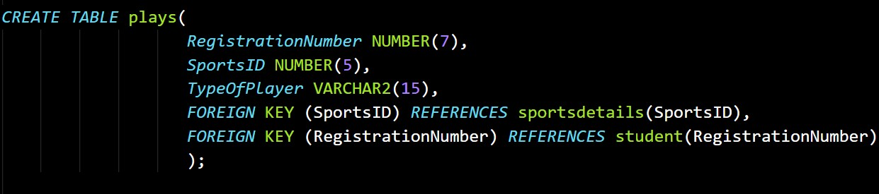

#### Table: library

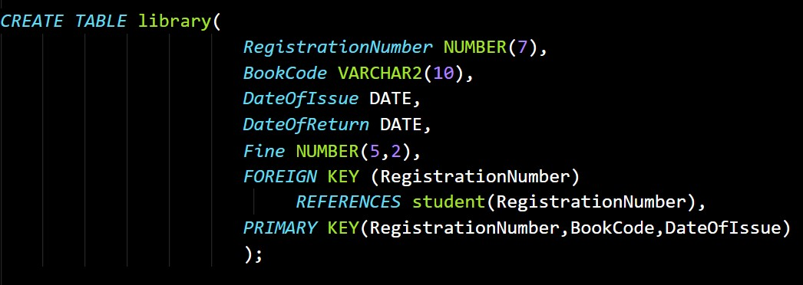

#### doctor

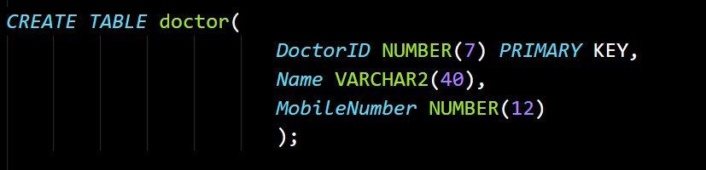

#### Table: dispensary

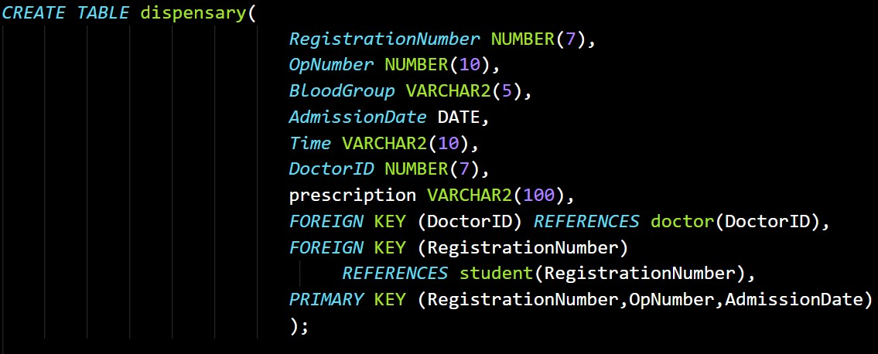

#### Table: studentsemresults

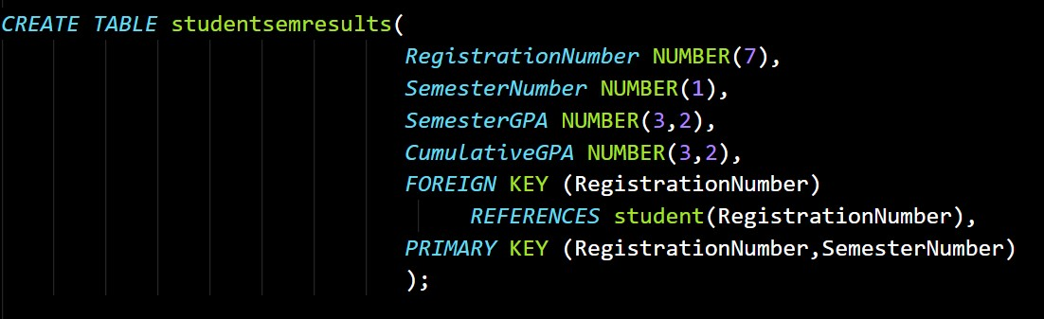

#### results

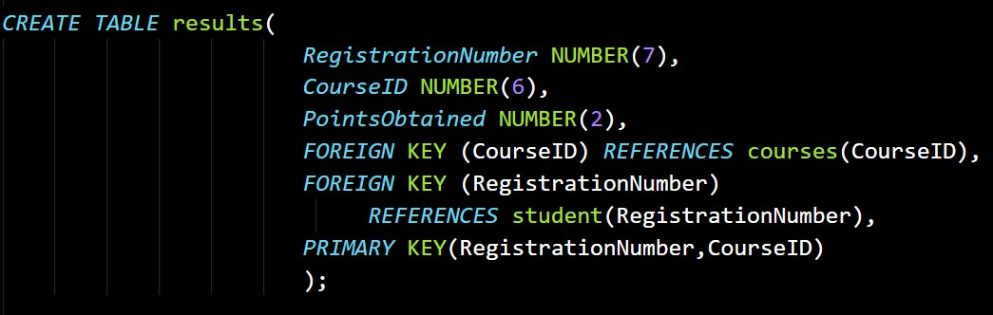

#### Table: registeredfor

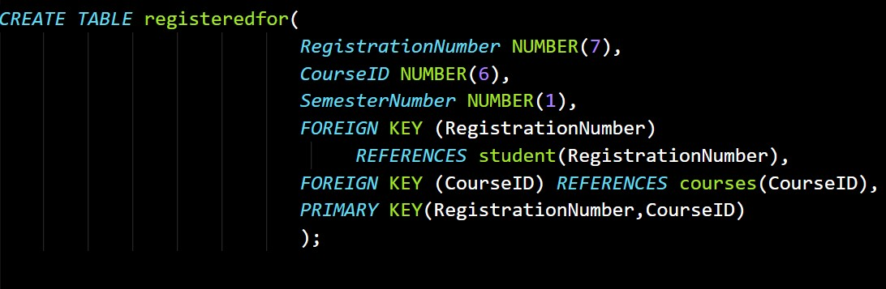

**Insertion of values into tables:**

**Table: mess**

INSERT INTO

mess(MessID,MessName,Contact,item1,item2,item3,item4)VALUES(41021,'IF A-A',7849561230,'Puri','Aloo Curry','Chole Curry',null);

INSERT INTO

mess(MessID,MessName,Contact,item1,item2,item3,item4)VALUES(41022,'IF A-B',8459761238,'Tomato Upma','Poha','Pav Bhaji','Egg');

INSERT INTO

mess(MessID,MessName,Contact,item1,item2,item3,item4)VALUES(41023,'IF A-C',9478561230,'Plain Parata','Aloo Curry','Maggi Noodles','Tomato Sauce');

INSERT INTO

mess(MessID,MessName,Contact,item1,item2,item3,item4)VALUES(41024,'M ess1',8475916234,'Masala Dosa','Chutney',null,null);

INSERT INTO

mess(MessID,MessName,Contact,item1,item2,item3,item4)VALUES(41025,'M ess2',7849561785,'Idli','Vada','Sambar','Chutney');

INSERT INTO

mess(MessID,MessName,Contact,item1,item2,item3,item4)VALUES(41026,'M ess3',9847561232,'Aloo Parata','Ajwain','Tomato Chutney','Curd');

#### Table: hostel

INSERT INTO

hostel(HostelID,HostelName,HostelIncharge,Address,Contact,MessID)VALUE S(10145,'Ultra Mega Hostels','Mahesh','Near IFC-A',9857641230,41021);

INSERT INTO

hostel(HostelID,HostelName,HostelIncharge,Address,Contact,MessID)VALUE S(10146,'1K Hall of Residence','Tarak','Near IFC-C',7849568751,41022);

INSERT INTO

hostel(HostelID,HostelName,HostelIncharge,Address,Contact,MessID)VALUE

S(10147,'International Hostel','Arjun','Behind Chemical

Department',7894785962,41024);

INSERT INTO

hostel(HostelID,HostelName,HostelIncharge,Address,Contact,MessID)VALUE S(10148,'Priyadharshini Hall','Kalyani','InFront of Main Gate',7895461278,41023);

INSERT INTO

hostel(HostelID,HostelName,HostelIncharge,Address,Contact,MessID)VALUE S(10149,'Sarojini Hall','Pooja','InFront of Time Square',9875461237,41025);

INSERT INTO

hostel(HostelID,HostelName,HostelIncharge,Address,Contact,MessID)VALUE S(10150,'VikramSarabhai Hall','Vijay','Behind Stadium',7895789687,41022);

INSERT INTO

hostel(HostelID,HostelName,HostelIncharge,Address,Contact,MessID)VALUE S(10151,'RajendraPrasad Hall','Sandeep','Near Post Office',9875689569,41026);

INSERT INTO

hostel(HostelID,HostelName,HostelIncharge,Address,Contact,MessID)VALUE S(10152,'Tagore Hall','Naveen','Beside Dispensary',9857848956,41021);

#### Table: sportsdetails

INSERT INTO

sportsdetails(SportsID,SportsName,SportIncharge,Contact)VALUES(107,'Bask etBall','Ravi Kumar',7895687956);

INSERT INTO

sportsdetails(SportsID,SportsName,SportIncharge,Contact)VALUES(118,'Bad minton','Suresh',7589641236);

INSERT INTO

sportsdetails(SportsID,SportsName,SportIncharge,Contact)VALUES(110,'Crick et','Ramesh',8457961230);

INSERT INTO

sportsdetails(SportsID,SportsName,SportIncharge,Contact)VALUES(112,'Volle y Ball','Dharma',7859647859);

INSERT INTO

sportsdetails(SportsID,SportsName,SportIncharge,Contact)VALUES(145,'Foot Ball','Rohit',9856985698);

INSERT INTO

sportsdetails(SportsID,SportsName,SportIncharge,Contact)VALUES(101,'Hock ey','Kattapa',7859686957);

INSERT INTO

sportsdetails(SportsID,SportsName,SportIncharge,Contact)VALUES(175,'Tenn is','Kattapa',7859875748);

#### Table: department

INSERT INTO

department(DepartmentID,Name,HOD,ContactNumber,EmailID)VALUES(101

,'Computer Science And Engineering','Dr P Radha

Krishna',7859648962,'csejntuk@jntuk.ac.in');

INSERT INTO

department(DepartmentID,Name,HOD,ContactNumber,EmailID)VALUES(201

,'Electronics and Communication Engineering','Dr ANJANEYULU L',8759462358,'ecejntuk@jntuk.ac.in');

INSERT INTO

department(DepartmentID,Name,HOD,ContactNumber,EmailID)VALUES(301

,'Electrical and Electronics Engineering','Dr SAILAJA KUMARI

M',8957475894,'eejntuk@jntuk.ac.in');

INSERT INTO

department(DepartmentID,Name,HOD,ContactNumber,EmailID)VALUES(401

,'Mechanical Engineering','Dr Adepu

Kumar',7859456758,'mejntuk@jntuk.ac.in');

INSERT INTO

department(DepartmentID,Name,HOD,ContactNumber,EmailID)VALUES(501

,'Civil Engineering','Dr P RATHISH

KUMAR',7989498288,'cejntuk@jntuk.ac.in');

INSERT INTO

department(DepartmentID,Name,HOD,ContactNumber,EmailID)VALUES(601

,'Chemical Engineering','Dr Surananai

Srinath',8748181718,'chejntuk@jntuk.ac.in');

INSERT INTO

department(DepartmentID,Name,HOD,ContactNumber,EmailID)VALUES(701

,'Materials and Metallurgical Engineering','Dr ASIT KUMAR

KHANRA',7181198198,'mmejntuk@jntuk.ac.in');

INSERT INTO

department(DepartmentID,Name,HOD,ContactNumber,EmailID)VALUES(801 ,'BioTechnological Engineering','Dr R Satish

Babu',9841161818,'btejntuk@jntuk.ac.in');

#### Table: student

INSERT INTO

student(RegistrationNumber,Name,Year,Section,EmailID,PhoneNumber,Depart mentID,HostelID,RoomNumber)VALUES(821943,'Manoj Kumer Reddy

P',2,'B','peta_821943@student.jntuk.ac.in',8688522956,101,10145,'A2-53');

INSERT INTO

student(RegistrationNumber,Name,Year,Section,EmailID,PhoneNumber,Depart mentID,HostelID,RoomNumber)VALUES(811913,'Sudireddy Dinesh

Reddy',2,'B','dinesh_811913@student.jntuk.ac.in',7702384122,101,10145,'B0-

04');

INSERT INTO

student(RegistrationNumber,Name,Year,Section,EmailID,PhoneNumber,Depart mentID,HostelID,RoomNumber)VALUES(821907,'Laksmi Prashanth

Gatram',2,'A','gatram_821907@student.jntuk.ac.in',7396579314,101,10145,'A0-

07');

INSERT INTO

student(RegistrationNumber,Name,Year,Section,EmailID,PhoneNumber,Depart mentID,HostelID,RoomNumber)VALUES(811905,'Rayana

Naveen',2,'A','rayana_811905@student.jntuk.ac.in',8074291732,201,10145,'A0-

05');

INSERT INTO

student(RegistrationNumber,Name,Year,Section,EmailID,PhoneNumber,Depart mentID,HostelID,RoomNumber)VALUES(811909,'Are RamaKrishna

Reddy',2,'B','ramakrishna_811909@student.jntuk.ac.in',8688925993,101,10145,' A0-03');

INSERT INTO

student(RegistrationNumber,Name,Year,Section,EmailID,PhoneNumber,Depart mentID,HostelID,RoomNumber)VALUES(811916,'ANISH

POLUDASU',2,'B','poludasu_811916@student.jntuk.ac.in',7702778019,401,101 45,'B0-30');

INSERT INTO

student(RegistrationNumber,Name,Year,Section,EmailID,PhoneNumber,Depart mentID,HostelID,RoomNumber)VALUES(821946,'RACHAMALLA VAMSHI KISHORE',2,'A','rachamalla_821946@student.jntuk.ac.in',9963601982,401,101 45,'B2-49');

INSERT INTO

student(RegistrationNumber,Name,Year,Section,EmailID,PhoneNumber,Depart mentID,HostelID,RoomNumber)VALUES(811966,'Sai Bharath Reddy

Lingala',2,'B','sai_bharath_811916@student.jntuk.ac.in',8555021723,101,10145,' B1-47');

INSERT INTO

student(RegistrationNumber,Name,Year,Section,EmailID,PhoneNumber,Depart mentID,HostelID,RoomNumber)VALUES(821945,'Asam Samba Siva

Reddy',2, 'A','asam_821945@student.jntuk.ac.in',8106570468,101,10145,'A2-

53');

INSERT INTO

student(RegistrationNumber,Name,Year,Section,EmailID,PhoneNumber,Depart mentID,HostelID,RoomNumber)VALUES(821934,'Mendu Rishika

Reddy',2,'B','mendu_821934@student.jntuk.ac.in',7093880980,401,10148,'C3-

04');

INSERT INTO

student(RegistrationNumber,Name,Year,Section,EmailID,PhoneNumber,Depart mentID,HostelID,RoomNumber)VALUES(871918,'Gaddam Rithvija

Reddy',2,'A','gaddam_871918@student.jntuk.ac.in',8341949494,801,10148,'C1-

42');

INSERT INTO

student(RegistrationNumber,Name,Year,Section,EmailID,PhoneNumber,Depart mentID,HostelID,RoomNumber)VALUES(911935,'Varkolu

Hemanth',2,'A','varkolu_911935@student.jntuk.ac.in',7013112151,301,10146,'A 1-46');

INSERT INTO

student(RegistrationNumber,Name,Year,Section,EmailID,PhoneNumber,Depart mentID,HostelID,RoomNumber)VALUES(911962,'Ravikala

Namratha',2,'C','ravikala_911962@student.jntuk.ac.in',9490258031,301,10148,' C1-45');

INSERT INTO

student(RegistrationNumber,Name,Year,Section,EmailID,PhoneNumber,Depart mentID,HostelID,RoomNumber)VALUES(931954,'Pavan

Musthala',2,'C','pavan_931954@student.jntuk.ac.in',9995556663,801,10145,'B2-

11');

INSERT INTO

student(RegistrationNumber,Name,Year,Section,EmailID,PhoneNumber,Depart mentID,HostelID,RoomNumber)VALUES(871928,'Chandana

sinderikeri',2,'B','sinderikeri@student.jntuk.ac.in',9676271501,101,10148,'D014');

**Table: plays**

INSERT INTO

plays(RegistrationNumber,SportsID,TypeOfPlayer)VALUES(811913,118,'AD VANCED');

INSERT INTO

plays(RegistrationNumber,SportsID,TypeOfPlayer)VALUES(821907,145,'SEN IOR');

INSERT INTO

plays(RegistrationNumber,SportsID,TypeOfPlayer)VALUES(821943,107,'BEG INNER');

INSERT INTO

plays(RegistrationNumber,SportsID,TypeOfPlayer)VALUES(821934,107,'AD VANCED');

INSERT INTO

plays(RegistrationNumber,SportsID,TypeOfPlayer)VALUES(811916,110,'AD VANCED');

INSERT INTO

plays(RegistrationNumber,SportsID,TypeOfPlayer)VALUES(811916,175,'AD VANCED');

INSERT INTO

plays(RegistrationNumber,SportsID,TypeOfPlayer)VALUES(821943,101,'ME DIUM');

INSERT INTO

plays(RegistrationNumber,SportsID,TypeOfPlayer)VALUES(821943,175,'AD VANCED');

INSERT INTO

plays(RegistrationNumber,SportsID,TypeOfPlayer)VALUES(811916,145,'AD VANCED');

#### Table: library

INSERT INTO

library(RegistrationNumber,BookCode,DateOfIssue,DateOfReturn,Fine)VALU ES(811913,'CS-1045','13-Jan-2020','15-MAY-2021',0);

INSERT INTO

library(RegistrationNumber,BookCode,DateOfIssue,DateOfReturn,Fine)VALU ES(821943,'EC-1035','12-MAY-2019','15-JAN-2020',10);

INSERT INTO

library(RegistrationNumber,BookCode,DateOfIssue,DateOfReturn,Fine)VALU ES(821934,'VS-2212','01-JAN-2021','15-JAN-2021',0);

INSERT INTO

library(RegistrationNumber,BookCode,DateOfIssue,DateOfReturn,Fine)VALU ES(821907,'MJ-8594','30-JAN-2021','26-FEB-2021',54.85);

INSERT INTO

library(RegistrationNumber,BookCode,DateOfIssue,DateOfReturn,Fine)VALU ES(811916,'TS-1081','11-FEB-2021','15-FEB-2021',0);

INSERT INTO

library(RegistrationNumber,BookCode,DateOfIssue,DateOfReturn,Fine)VALU ES(811913,'YT-9758','16-SEP-2020','18-MAR-2021',0);

INSERT INTO

library(RegistrationNumber,BookCode,DateOfIssue,DateOfReturn,Fine)VALU ES(821943,'LM-4589','14-FEB-2021','28-FEB-2021',50);

INSERT INTO

library(RegistrationNumber,BookCode,DateOfIssue,DateOfReturn,Fine)VALU ES(871928,'MH-8954','14-FEB-2021','25-MAR-2021',85.32);

INSERT INTO

library(RegistrationNumber,BookCode,DateOfIssue,DateOfReturn,Fine)VALU ES(931954,'EC-4356','08-MAY-2020','21-JAN-2021',65);

INSERT INTO

library(RegistrationNumber,BookCode,DateOfIssue,DateOfReturn,Fine)VALU ES(821943,'BS-1051','12-JAN-2021','15-JUL-2021',10);

INSERT INTO

library(RegistrationNumber,BookCode,DateOfIssue,DateOfReturn,Fine)VALU

ES(821945,'EC-4352','12-AUG-2020','23-DEC-2020',15);

#### Table: doctor

INSERT INTO

doctor(DoctorID,Name,MobileNumber)VALUES(5784916,'Abraham',7859462 463);

INSERT INTO

doctor(DoctorID,Name,MobileNumber)VALUES(5784917,'Harish',785964859

6);

INSERT INTO

doctor(DoctorID,Name,MobileNumber)VALUES(5784918,'Kalyan',784956123

5);

INSERT INTO

doctor(DoctorID,Name,MobileNumber)VALUES(5784919,'Rajesh',879657946

6);

INSERT INTO

doctor(DoctorID,Name,MobileNumber)VALUES(5784920,'Suresh',785946854

5);

#### Table: dispensary

INSERT INTO

dispensary(RegistrationNumber,OpNumber,BloodGroup,AdmissionDate,Time, prescription,DoctorID)VALUES(821946,8415,'A+ve','12-JAN-2021','10:40 AM','2-PARACETMOL,2-COLPOL',5784916);

INSERT INTO

dispensary(RegistrationNumber,OpNumber,BloodGroup,AdmissionDate,Time,

prescription,DoctorID)VALUES(811909,8485,'B+ve','18-FEB-2021','12:50 PM','DOXYCYCLIN,AZITHROMYCIN',5784917);

INSERT INTO

dispensary(RegistrationNumber,OpNumber,BloodGroup,AdmissionDate,Time,

prescription,DoctorID)VALUES(911935,7496,'AB-ve','19-MAR-2021','05:30 AM','VITAMIN-C,ZINCOVIT,PARACETMOL',5784920);

INSERT INTO

dispensary(RegistrationNumber,OpNumber,BloodGroup,AdmissionDate,Time,

prescription,DoctorID)VALUES(931954,6957,'O+ve','10-JUNE-2021','05:00

AM','2-COLPOL,AZITHROMYCIN,ZINCOVIT',5784918);

dispensary(RegistrationNumber,OpNumber,BloodGroup,AdmissionDate,Time,

prescription,DoctorID)VALUES(911935,5973,'O-ve','18-FEB-2021','12:00

PM','AMOXYCYCLIN,D-VITAMIN,PANTOP-40,VOLMIZESTCH-

40',5784919);

INSERT INTO

dispensary(RegistrationNumber,OpNumber,BloodGroup,AdmissionDate,Time, prescription,DoctorID)VALUES(871928,4412,'O-VE','03-APR-2021','02:30 PM','VELOTISE,DOLO-650',5784920);

INSERT INTO

dispensary(RegistrationNumber,OpNumber,BloodGroup,AdmissionDate,Time, prescription,DoctorID)VALUES(821946,5515,'O+ve','01-APR-2021','01:30 PM','CIPLA,PARACETMOL',5784918);

INSERT INTO

dispensary(RegistrationNumber,OpNumber,BloodGroup,AdmissionDate,Time, prescription,DoctorID)VALUES(811916,8425,'O+ve','18-JUN-2020','11:20 AM','DOLO-650,COLD-ACT',5784918);

#### Table: courses

INSERT INTO

courses(CourseID,CourseName,NumberOfCredits)VALUES(1011,'Data Structures and Algorithms',4);

INSERT INTO

courses(CourseID,CourseName,NumberOfCredits)VALUES(1012,'DESIGN,A NALYSIS OF ALGORITHMS',3);

INSERT INTO

courses(CourseID,CourseName,NumberOfCredits)VALUES(1013,'COMPUTE R ARCHITECTURE',3);

INSERT INTO

courses(CourseID,CourseName,NumberOfCredits)VALUES(1014,'DATABAS E MANAGEMENT SYSTEMS',4);

INSERT INTO

courses(CourseID,CourseName,NumberOfCredits)VALUES(1015,'OBJECT

ORIENTED PROGRAMMING',3); courses(CourseID,CourseName,NumberOfCredits)VALUES(2011,'Control System Engineering',3);

INSERT INTO

courses(CourseID,CourseName,NumberOfCredits)VALUES(2012,'Transmissio n Lines, EM waves',3);

INSERT INTO

courses(CourseID,CourseName,NumberOfCredits)VALUES(2013,'Electronic Devices,Circuits',4);

INSERT INTO

courses(CourseID,CourseName,NumberOfCredits)VALUES(3011,'Electrical Instrumentation',3);

INSERT INTO

courses(CourseID,CourseName,NumberOfCredits)VALUES(3012,'Circuit Theory',3);

INSERT INTO

courses(CourseID,CourseName,NumberOfCredits)VALUES(3013,'Analog

Electronics',3);

INSERT INTO

courses(CourseID,CourseName,NumberOfCredits)VALUES(4011,'Numerical

Statistical Methods',3);

INSERT INTO

courses(CourseID,CourseName,NumberOfCredits)VALUES(4012,'Dynamics of Machinery',4);

INSERT INTO

courses(CourseID,CourseName,NumberOfCredits)VALUES(4013,'Turbomachi nes',3);

INSERT INTO

courses(CourseID,CourseName,NumberOfCredits)VALUES(8011,'BIOSENSO

RS',3);

INSERT INTO

courses(CourseID,CourseName,NumberOfCredits)VALUES(8012,'Mathematic s-4',3); courses(CourseID,CourseName,NumberOfCredits)VALUES(8013,'GREEN TECHNOLOGY',3);

#### Table: registeredfor

INSERT INTO

registeredfor(RegistrationNumber,CourseID,SemesterNumber)VALUES(81191 3,1011,3);

INSERT INTO

registeredfor(RegistrationNumber,CourseID,SemesterNumber)VALUES(81191 3,1012,4);

INSERT INTO

registeredfor(RegistrationNumber,CourseID,SemesterNumber)VALUES(82190 7,1011,3);

INSERT INTO

registeredfor(RegistrationNumber,CourseID,SemesterNumber)VALUES(82194 3,1011,3);

INSERT INTO

registeredfor(RegistrationNumber,CourseID,SemesterNumber)VALUES(82194 3,1015,4);

INSERT INTO

registeredfor(RegistrationNumber,CourseID,SemesterNumber)VALUES(82190 7,1014,4);

INSERT INTO

registeredfor(RegistrationNumber,CourseID,SemesterNumber)VALUES(82194 6,4011,3);

INSERT INTO

registeredfor(RegistrationNumber,CourseID,SemesterNumber)VALUES(82194 6,4012,4);

INSERT INTO

registeredfor(RegistrationNumber,CourseID,SemesterNumber)VALUES(81190 9,1011,4); registeredfor(RegistrationNumber,CourseID,SemesterNumber)VALUES(81190 9,1013,3);

INSERT INTO

registeredfor(RegistrationNumber,CourseID,SemesterNumber)VALUES(81190 5,2011,4);

INSERT INTO

registeredfor(RegistrationNumber,CourseID,SemesterNumber)VALUES(81190 5,2013,3);

INSERT INTO

registeredfor(RegistrationNumber,CourseID,SemesterNumber)VALUES(91196 2,3013,3);

INSERT INTO

registeredfor(RegistrationNumber,CourseID,SemesterNumber)VALUES(91196 2,3012,4);

INSERT INTO

registeredfor(RegistrationNumber,CourseID,SemesterNumber)VALUES(93195 4,8011,3);

INSERT INTO

registeredfor(RegistrationNumber,CourseID,SemesterNumber)VALUES(93195 4,8013,3);

#### Table: results

INSERT INTO

results(RegistrationNumber,CourseID,PointsObtained)VALUES(811913,1011, 10);

INSERT INTO

results(RegistrationNumber,CourseID,PointsObtained)VALUES(811913,1012, 10);

INSERT INTO

results(RegistrationNumber,CourseID,PointsObtained)VALUES(821907,1011, 10); results(RegistrationNumber,CourseID,PointsObtained)VALUES(821943,1011,

9);

INSERT INTO

results(RegistrationNumber,CourseID,PointsObtained)VALUES(821943,1015,

9);

INSERT INTO

results(RegistrationNumber,CourseID,PointsObtained)VALUES(821907,1014,

9);

INSERT INTO

results(RegistrationNumber,CourseID,PointsObtained)VALUES(821946,4011,

7);

INSERT INTO

results(RegistrationNumber,CourseID,PointsObtained)VALUES(821946,4012,

8);

INSERT INTO

results(RegistrationNumber,CourseID,PointsObtained)VALUES(811909,1011,

9);

INSERT INTO

results(RegistrationNumber,CourseID,PointsObtained)VALUES(811909,1013,

7);

INSERT INTO

results(RegistrationNumber,CourseID,PointsObtained)VALUES(811905,2011,

8);

INSERT INTO

results(RegistrationNumber,CourseID,PointsObtained)VALUES(811905,2013,

9);

INSERT INTO

results(RegistrationNumber,CourseID,PointsObtained)VALUES(911962,3013, 10);

INSERT INTO

results(RegistrationNumber,CourseID,PointsObtained)VALUES(911962,3012,

8); results(RegistrationNumber,CourseID,PointsObtained)VALUES(931954,8011,

9);

INSERT INTO

results(RegistrationNumber,CourseID,PointsObtained)VALUES(931954,8013,

7);

#### Table: studentsemresults

INSERT INTO

studentsemresults(RegistrationNumber,SemesterNumber,SemesterGPA,Cumula tiveGPA)VALUES(821943,2,9.91,9.45);

INSERT INTO

studentsemresults(RegistrationNumber,SemesterNumber,SemesterGPA,Cumula tiveGPA)VALUES(821907,2,9.92,9.56);

INSERT INTO

studentsemresults(RegistrationNumber,SemesterNumber,SemesterGPA,Cumula tiveGPA)VALUES(811909,2,9.65,9.36);

INSERT INTO

studentsemresults(RegistrationNumber,SemesterNumber,SemesterGPA,Cumula tiveGPA)VALUES(821943,3,9.45,9.25);

INSERT INTO

studentsemresults(RegistrationNumber,SemesterNumber,SemesterGPA,Cumula tiveGPA)VALUES(811913,2,9.35,9.17);

INSERT INTO

studentsemresults(RegistrationNumber,SemesterNumber,SemesterGPA,Cumula tiveGPA)VALUES(821907,3,9.25,9.65);

INSERT INTO

studentsemresults(RegistrationNumber,SemesterNumber,SemesterGPA,Cumula tiveGPA)VALUES(811916,2,9.57,9.35);

INSERT INTO

studentsemresults(RegistrationNumber,SemesterNumber,SemesterGPA,Cumula tiveGPA)VALUES(931954,3,8.35,8.27); studentsemresults(RegistrationNumber,SemesterNumber,SemesterGPA,Cumula tiveGPA)VALUES(911962,2,9.25,9.17);

INSERT INTO

studentsemresults(RegistrationNumber,SemesterNumber,SemesterGPA,Cumula tiveGPA)VALUES(821946,2,8.57,9.56);

INSERT INTO

studentsemresults(RegistrationNumber,SemesterNumber,SemesterGPA,Cumula tiveGPA)VALUES(821946,3,9.25,9.62);

INSERT INTO

studentsemresults(RegistrationNumber,SemesterNumber,SemesterGPA,Cumula tiveGPA)VALUES(821907,4,9.16,9.06);

INSERT INTO

studentsemresults(RegistrationNumber,SemesterNumber,SemesterGPA,Cumula tiveGPA)VALUES(821934,2,9.06,9.00);

INSERT INTO

studentsemresults(RegistrationNumber,SemesterNumber,SemesterGPA,Cumula tiveGPA)VALUES(811905,3,9.13,9.10);

INSERT INTO

studentsemresults(RegistrationNumber,SemesterNumber,SemesterGPA,Cumula tiveGPA)VALUES(821945,2,9.09,9.00);

#### Table: faculty

INSERT INTO faculty(FacultyID,DepartmentID,Name,MobileNumber,AreasOfInterest,Design ation,EmailID)VALUES(10111,101,'Dr. K.

RAMESH',8702462712,'Architectures and Coding infrastructures in Computer

Networks, Service-oriented, Distributed','Associate

Professor','srirameesh@yahoo.com');

INSERT INTO

faculty(FacultyID,DepartmentID,Name,MobileNumber,AreasOfInterest,Design ation,EmailID)VALUES(10112,101,'Dr. P. Venkata Subba Reddy',8332969417,'Algorithms and Graph Theory','Assistant Professor','pvsr@jntuk.ac.in');

INSERT INTO faculty(FacultyID,DepartmentID,Name,MobileNumber,AreasOfInterest,Design ation,EmailID)VALUES(10113,101,'Dr. R.

PADMAVATHY',8702468738,'Cryptanalysis and Network Security','Associate Professor','rpadma@jntuk.ac.in');

INSERT INTO

faculty(FacultyID,DepartmentID,Name,MobileNumber,AreasOfInterest,Design ation,EmailID)VALUES(10114,101,'Dr. T

RAMAKRISHNUDU',9866876842,'Data mining-Association rule mining,

Distributed data mining., Big Data Analytics, Web Mining','Assistant Professor','trk@jntuk.ac.in');

INSERT INTO

faculty(FacultyID,DepartmentID,Name,MobileNumber,AreasOfInterest,Design ation,EmailID)VALUES(10115,101,'Dr. Sujit Das',9434588993,'Fuzzy Set;

Hybridized Fuzzy Soft Set; Uncertain Decision Making','Assistant Professor','sujit.das@jntuk.ac.in');

INSERT INTO

faculty(FacultyID,DepartmentID,Name,MobileNumber,AreasOfInterest,Design ation,EmailID)VALUES(20111,201,'Dr . Mrs. VAKULA

D',8332969362,'Antenna Arrays, Multi-function Antennas, Ultra Wide Band

Antennas','Associate Professor','vakula@jntuk.ac.in');

INSERT INTO

faculty(FacultyID,DepartmentID,Name,MobileNumber,AreasOfInterest,Design ation,EmailID)VALUES(20112,201,'Dr. V. RAMA',9440762744,'Bio-Medical

Signal Processing; Bio Medical Instrumentation; Artificial Neural

Networks','Assistant Professor','vr.jntuk@gmail.com');

INSERT INTO

faculty(FacultyID,DepartmentID,Name,MobileNumber,AreasOfInterest,Design ation,EmailID)VALUES(20113,201,'SRI. SARANGAM

K',8702462445,'Design and implementation of universal filter using differential voltage','Assistant Professor','sarangam_7@jntuk.ac.in');

INSERT INTO

faculty(FacultyID,DepartmentID,Name,MobileNumber,AreasOfInterest,Design ation,EmailID)VALUES(20114,201,'Vadthiya Narendar',9795235922,'Beyond CMOS, Nanoscale device design and modeling, Modeling and simulation of semiconductor devices','Assistant Professor','narendarv@jntuk.ac.in');

INSERT INTO

faculty(FacultyID,DepartmentID,Name,MobileNumber,AreasOfInterest,Design ation,EmailID)VALUES(30111,301,'Narasimharaju B. L',8702462247,'LED

Drivers for Lighting Systems,Grid integration of solar energy ','Associate Professor','blnraju@jntuk.ac.in');

INSERT INTO

faculty(FacultyID,DepartmentID,Name,MobileNumber,AreasOfInterest,Design

ation,EmailID)VALUES(30112,301,'Dr. BHOOKYA

NAGU',8332969287,'Solar PV , Fuel Cell , Wind Power,HVDC and AI

Techniques','Assistant Professor','nagubhukya@jntuk.ac.in');

INSERT INTO

faculty(FacultyID,DepartmentID,Name,MobileNumber,AreasOfInterest,Design

ation,EmailID)VALUES(40111,401,'Dr. JOSEPH DAVIDSON

M',8332969324,' Metal Forming, CAD/CAM','Associate

Professor','mjdavidson2001@yahoo.co.in');

INSERT INTO

faculty(FacultyID,DepartmentID,Name,MobileNumber,AreasOfInterest,Design

ation,EmailID)VALUES(40112,401,'Dr P Vamsi

Krishna',9440843609,'Application of solid lubricants in machining process','Associate Professor','vamsikrishna@jntuk.ac.in');

INSERT INTO

faculty(FacultyID,DepartmentID,Name,MobileNumber,AreasOfInterest,Design ation,EmailID)VALUES(80111,801,'Rathnaprabha

D',9494668822,'Biotechnology, Plant Biotechnology(Various types Tissue

Cultures) and Molecular biology','Assistant

Professor','rathnaprabhad@jntuk.ac.in');

INSERT INTO faculty(FacultyID,DepartmentID,Name,MobileNumber,AreasOfInterest,Design ation,EmailID)VALUES(80112,801,'Dr.

Priya',8749561334,'BioTechnology,Molecular biology','Assistant

Professor','priya@jntuk.ac.in');

#### teaches

INSERT INTO teaches(FacultyID,CourseID)VALUES(10111,1011);

INSERT INTO teaches(FacultyID,CourseID)VALUES(10112,1012);

INSERT INTO teaches(FacultyID,CourseID)VALUES(10113,1013);

INSERT INTO teaches(FacultyID,CourseID)VALUES(10114,1014);

INSERT INTO teaches(FacultyID,CourseID)VALUES(10115,1015);

INSERT INTO teaches(FacultyID,CourseID)VALUES(20111,2011);

INSERT INTO teaches(FacultyID,CourseID)VALUES(20112,2012);

INSERT INTO teaches(FacultyID,CourseID)VALUES(20113,2013);

INSERT INTO teaches(FacultyID,CourseID)VALUES(30111,3011);

INSERT INTO teaches(FacultyID,CourseID)VALUES(30112,3012);

INSERT INTO teaches(FacultyID,CourseID)VALUES(40111,4011);

INSERT INTO teaches(FacultyID,CourseID)VALUES(40112,4012);

INSERT INTO teaches(FacultyID,CourseID)VALUES(80111,8011);

INSERT INTO teaches(FacultyID,CourseID)VALUES(80112,8012); **Displaying Tables:**

**Table: mess**

#### SELECT * FROM mess;

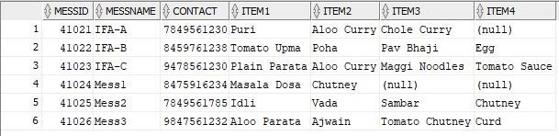

#### Table: hostel SELECT * FROM hostel;

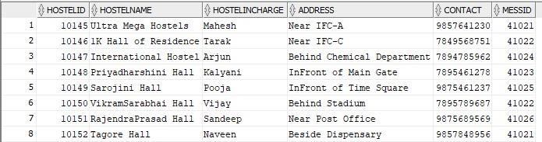

#### Table: sportsdetails SELECT * FROM sportsdetails;

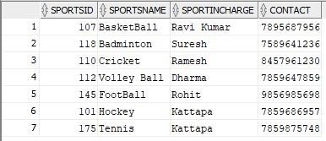

#### department SELECT * FROM department;

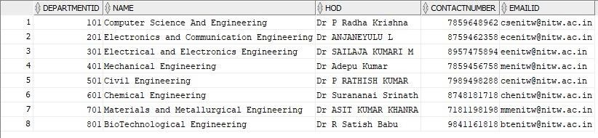

#### Table: faculty SELECT * FROM faculty;

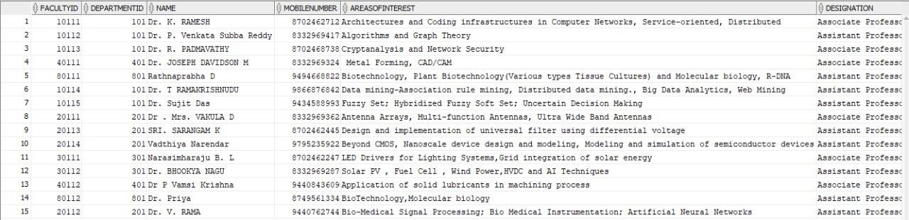

#### Table: courses SELECT * FROM courses;

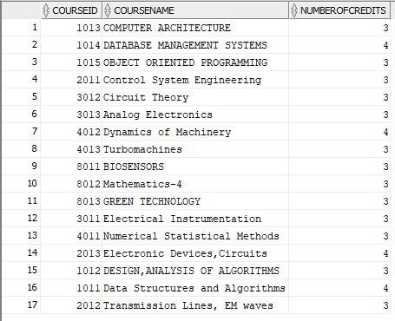

#### teaches teaches;

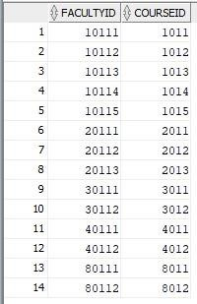

#### Table: student SELECT * FROM student;

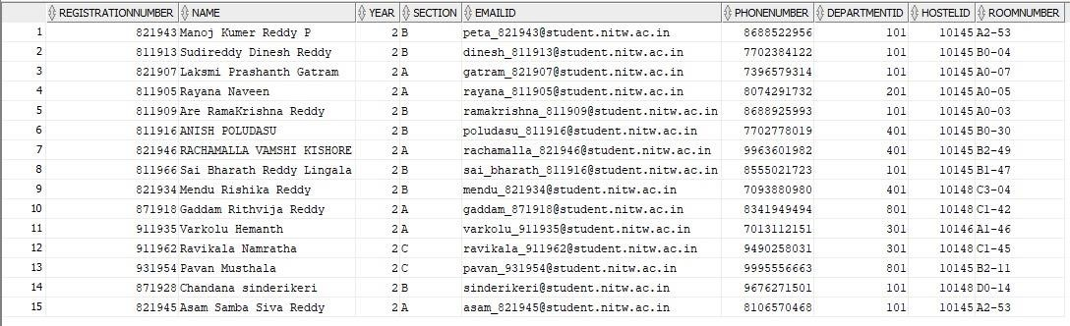

#### plays plays;

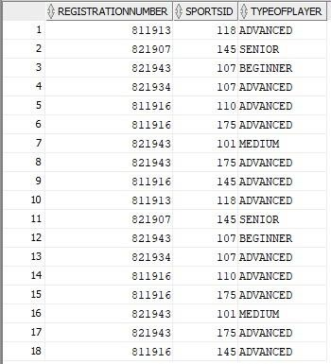

#### Table: library SELECT * FROM library;

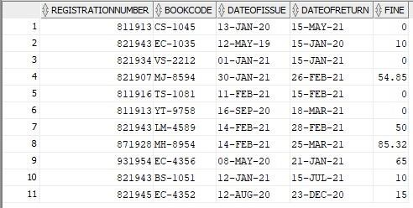

#### doctor doctor;

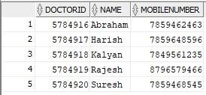

#### Table: dispensary SELECT * FROM dispensary;

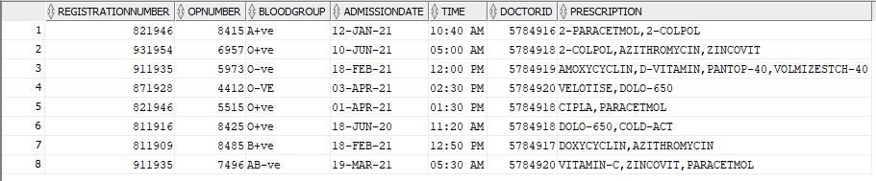

#### Table: studentsemresults SELECT * FROM studentsemresults;

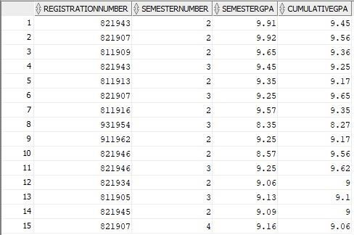

#### results

**results;**

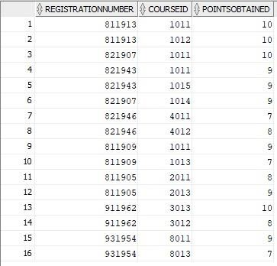

#### Table: registeredfor SELECT * FROM registeredfor;

